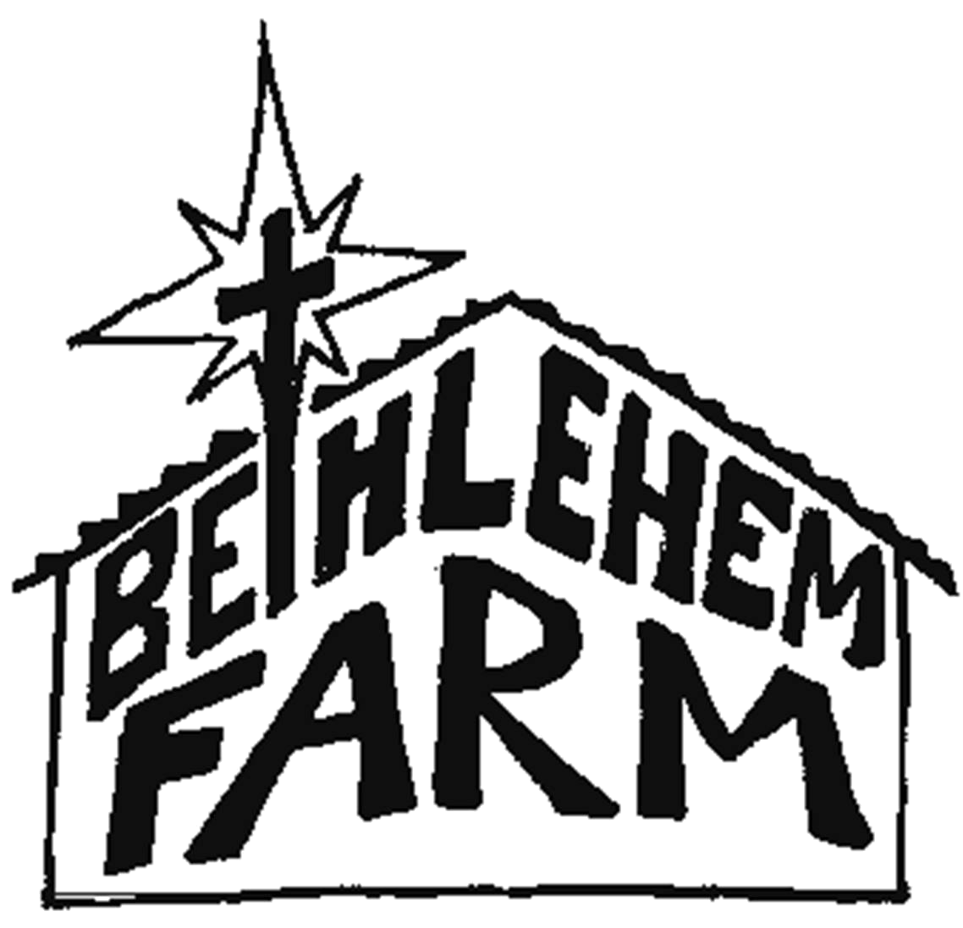
VOLUNTEER CONTRACT
P.O. Box 415
Talcott
West Virginia
24981
304.445.7143
bethlehemfarm.net

(Completion of the Volunteer Contract is required for the Bethlehem Farm Trip)
I am fully aware that the volunteer experience at Bethlehem Farm will require me to make personal sacrifices of which I may not be accustomed. I agree to live this week in simplicity, doing without some of the conveniences to which I am accustomed. I will work and complete tasks to the best of my ability.

I realize that living and working together in community will require me to display patience and respect toward all members of the group. I realize the importance of following a schedule and the guidance and instruction of the leaders. I am willing to comply with the requests of the leadership and be flexible with what is asked of me.

I am aware that the week will involve a focus on prayer based on the Catholic tradition. I am open to this experience and will actively participate to the degree that I am able.

I further realize that I will be visiting an area where the culture and the customs may differ from my own. I will treat all people at the Farm and in the surrounding community with respect.

I agree not to involve myself in drugs, alcohol, or sex while at Bethlehem Farm.

I agree to follow the Bethlehem Farm COVID-19 guidelines to protect the health of the community.

I give consent for Bethlehem Farm to videotape and photograph me during my volunteer week. I understand these photographs and videotapes may be used for advertising and/or orientation materials for Bethlehem Farm including the Farm website. I give my permission for possible participation in videotaping and/or still photographs.

I give consent for Bethlehem Farm to share my address, phone number, and email address with the other volunteers that attend the group week.
I dedicate myself to be an active participant in this week of service, prayer, simplicity, and community as an experience of Christian living.

__________________________________________ _______________
Signature Date
__________________________________________ _______________
Parent/Guardian Signature (if under 18) Date

Name (print) ____________________________________________________

E-Mail: ________________________________________________________

Address (permanent) ________________________________________________________
_________________________ Phone _______________________
Address (current) ______________________________________________________________
_________________________ Phone _______________________
Current School or Work _______________________________________________
Class: High School: SO JR SR College: FR SO JR SR Age __________
Home Parish ________________________________________________________
Religious Affiliation ________________________________________________________
Other (information we should know ahead of time): __________________________________________

Have you ever been to Bethlehem Farm (formerly known as the ‘John Filliger Catholic Worker Farm) before? Y N If so, When?

Please answer this question (use the reverse side if needed): What is your motivation for spending a week at Bethlehem Farm?

Revision 5/10/2020

